Green Beans Ltd.
Gerard Breen
5th July 2015

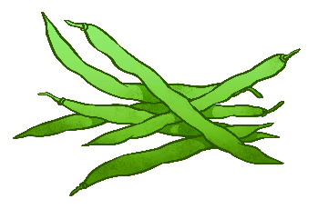
Manager
Hilltop Hotel

To the Managers and Staff at the Hilltop Hotel
What a success! Green Beans has now enjoyed its first Annual Conference ‘Going and Staying Green’. The event has had excelent reviews.
On behalf of the Green Beans Ltd. Board of Directors, I want to extend a heart-felt thank you for your commitments to making this event so successful. It was the vision of the Board of Directors and the Planning Committee to inform, entertain, and provide a networking forum for all local busineses in a comfortable enviroment. We have managed to engage now with over 80% of the local businesses.
Your generus contribution helped make our vision a reality by helping to offset the cost of holding the Conference in an environment as beatiful and professional as the Hilltop Hotel.
As we continue to grow, please know that partnerships with our sponsers are vital to the success of this chapter. You are appreciated.
Thanks again. Sincerely,
Gerard Breen
Green Beans Ltd

